**EXP NO: 01**

**DATE: 13-04-24**

**Aim:**

Create a simple cloud software application for Flight Reservation System using any Cloud Service Provider to demonstrate SaaS include the necessary fields such as one way, round trip, From, to, Departure, Departure, Travelers & Class, Fare Type, International and Domestic Flights etc.

**Implementation:**

**1. Go to Zoho.com and login/signup**

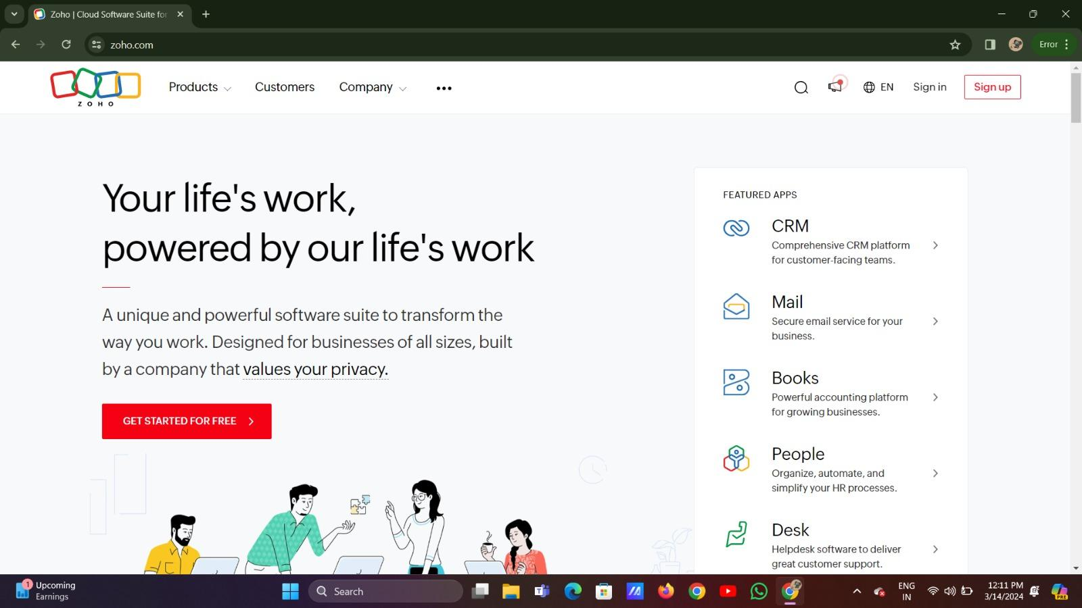

**2. Go to Creator**

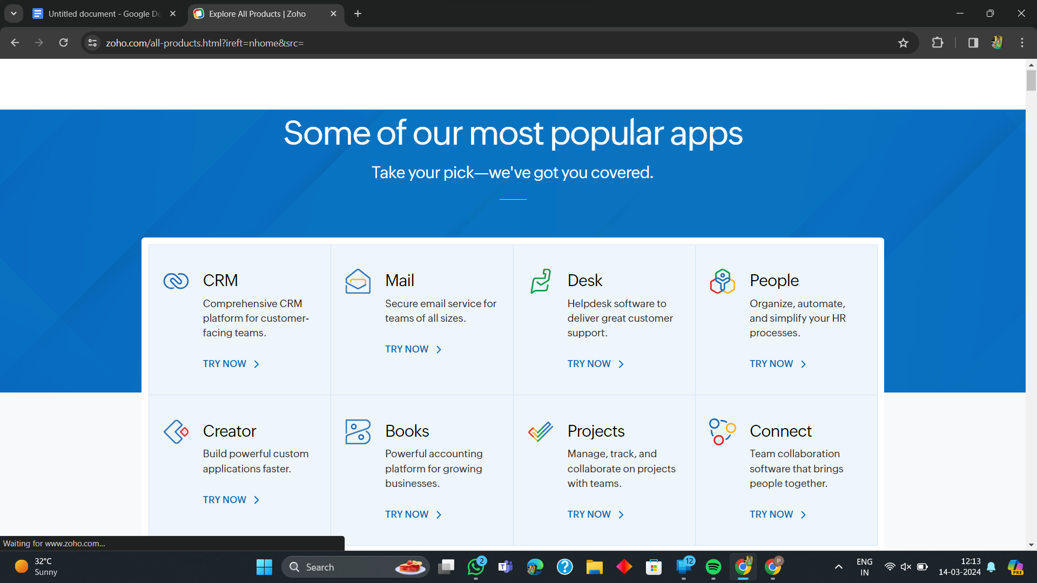

**3. Create A New Application**

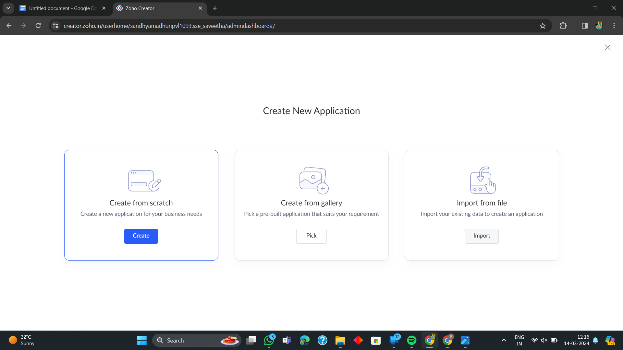

**4. Given Application Name**

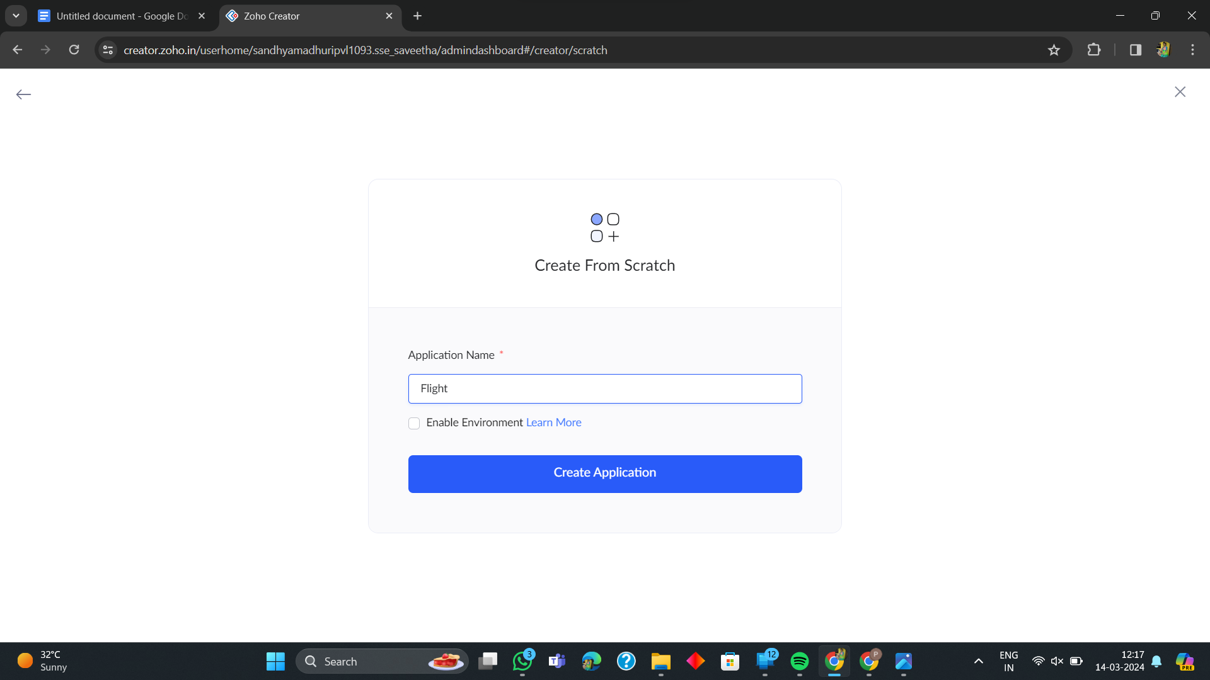

**5. Create New Form**

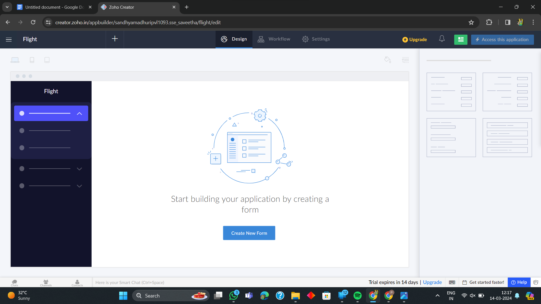

**6. Select Form and Give Name**

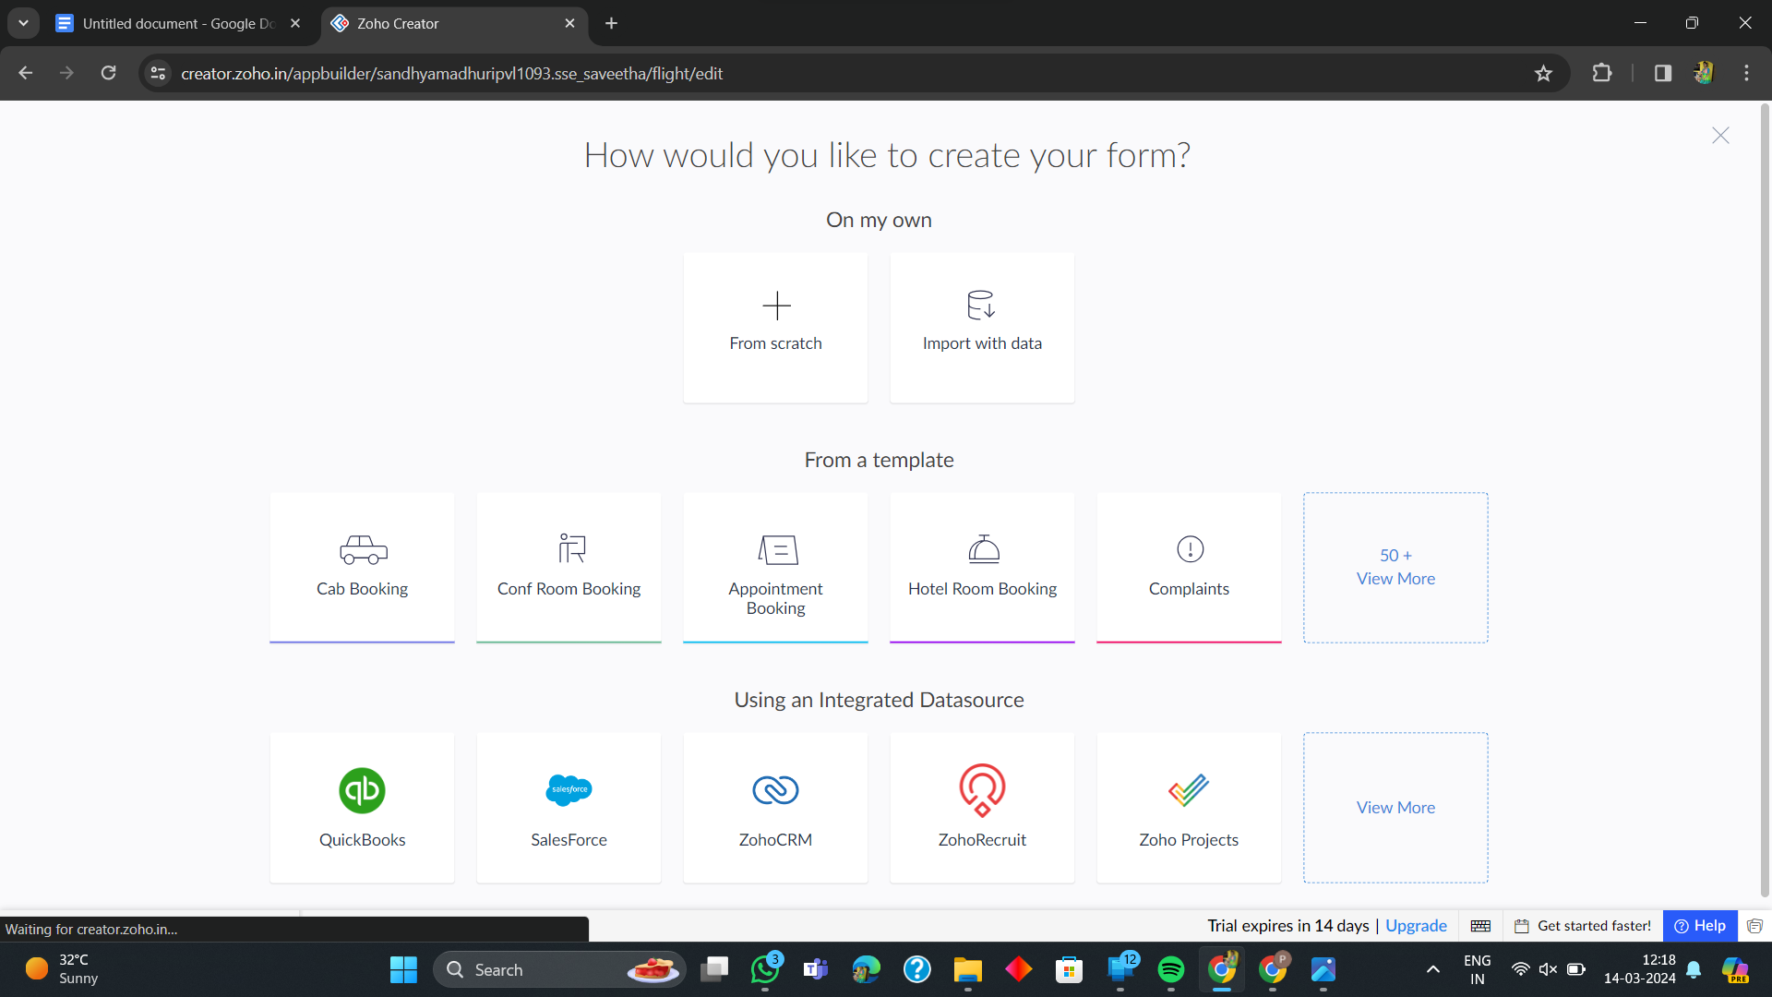

**7. Drag necessary fields**

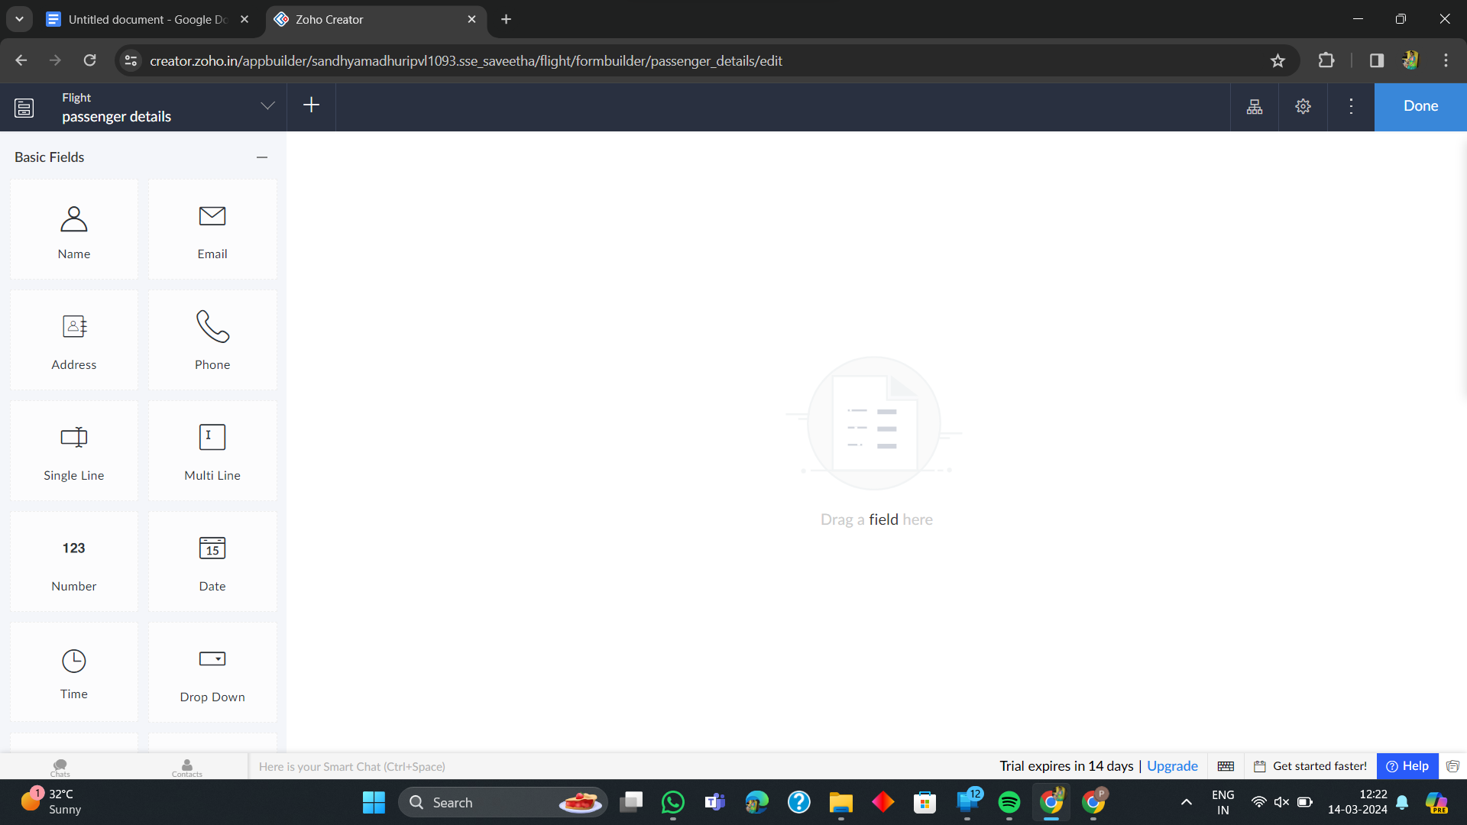

**8. The Software Has been created**

